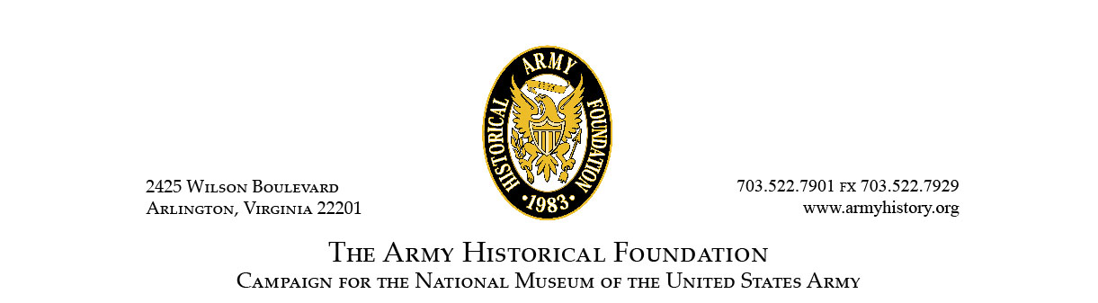
The Army Historical Foundation

Since its establishment in 1775, the U.S. Army has played an integral role in the history of our nation. Soldiers have seen action in every major conflict in which the United States has fought throughout our nation’s history. Without the men and women who have served, the United States would not be what it is today. The Army Historical Foundation is dedicated to remembering and honoring their legacies.

Established in 1983 as a member-based, charitable 501(c)(3) nonprofit organization, the Foundation seeks to educate future Americans to fully appreciate the sacrifices that generations of American Soldiers have made to safeguard the freedoms of this nation. Our funding helps to refurbish historic Army buildings, acquire and conserve Army historical art and artifacts, support Army history educational programs, research, and publication of historical materials on the American Soldier, and provide support and counsel to private and governmental organizations committed to the same goals.

In 2009, the U.S. Army designated The Army Historical Foundation as the official fundraiser for the construction of the National Museum of the United States Army. In 2015, the Foundation was charged with overseeing the completion of the museum’s design and construction. The Foundation broke ground on September 14, 2016. At this time, approximately $140 million of the $200 million needed for the construction had been raised. The Museum is expected to open in late 2019.

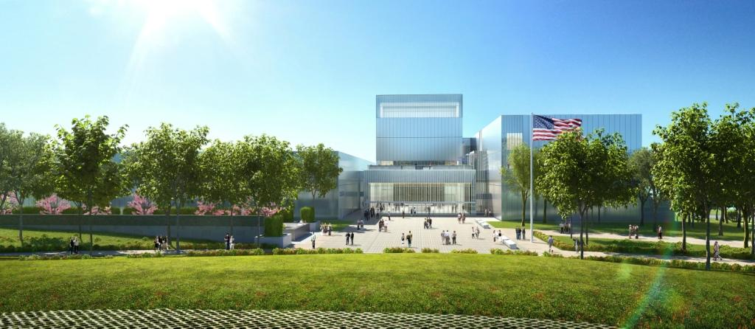

National Museum of the United States Army

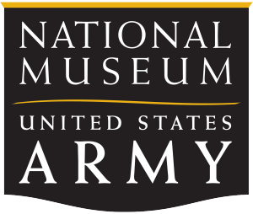
The National Museum of the United States Army will occupy over 80 acres of publicly-accessible land at Fort Belvoir, Va., less than 30 minutes south of our nation’s capital in Washington, D.C. The main building will be approximately 185,000 square feet and display artifacts, documents, images, and selections from the Army Art Collection that tell the complete story of the U.S. Army since its founding in 1775. The vast majority of these rare and priceless artifacts have never been seen by the American people.

A series of chronological and thematic galleries will show visitors what it means to be a Soldier in times of both war and peace. The three main galleries will be Soldier Stories, Fighting for the Nation, and Army and Society. The Fighting for the Nation Gallery will be divided into six sub-galleries, each covering a different period in the Army’s history, starting with the Revolutionary War and ending with the most recent wars in Iraq and Afghanistan.

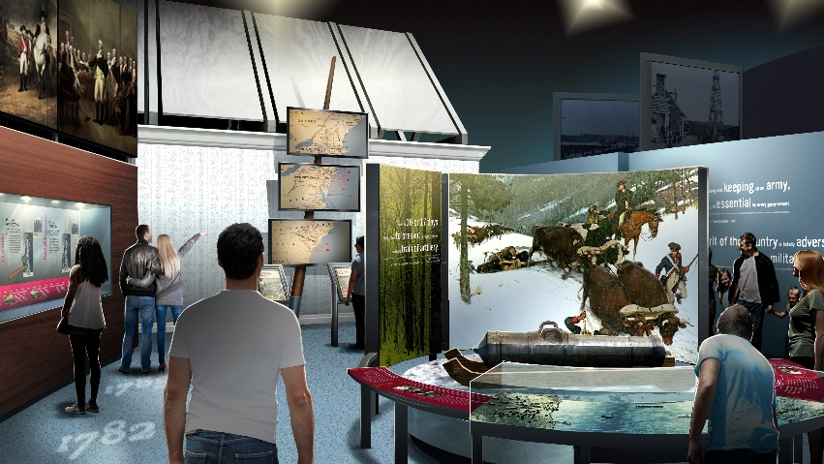
“Service and Sacrifice” will be the dominant theme throughout the Museum. Galleries will show the Army’s strength as an agent of peace and nation-building. Exhibits and displays will also showcase the ingenuity of the American Soldier. The U.S. Army has greatly aided the nation’s progress and prosperity. Soldiers have conducted countless missions in the areas of exploration and discovery, science and technology, communications and cooperation, and recovery and disaster relief. The Museum will also include an Experiential Learning Center, a unique, state-of-the-art interactive resource center featuring G-STEM (geography, science, technology, engineering, and mathematics) educational programs specifically designed for middle school-aged children.

The property surrounding the main building will include a memorial garden, amphitheater, parade ground, and trail.

The Museum Experience

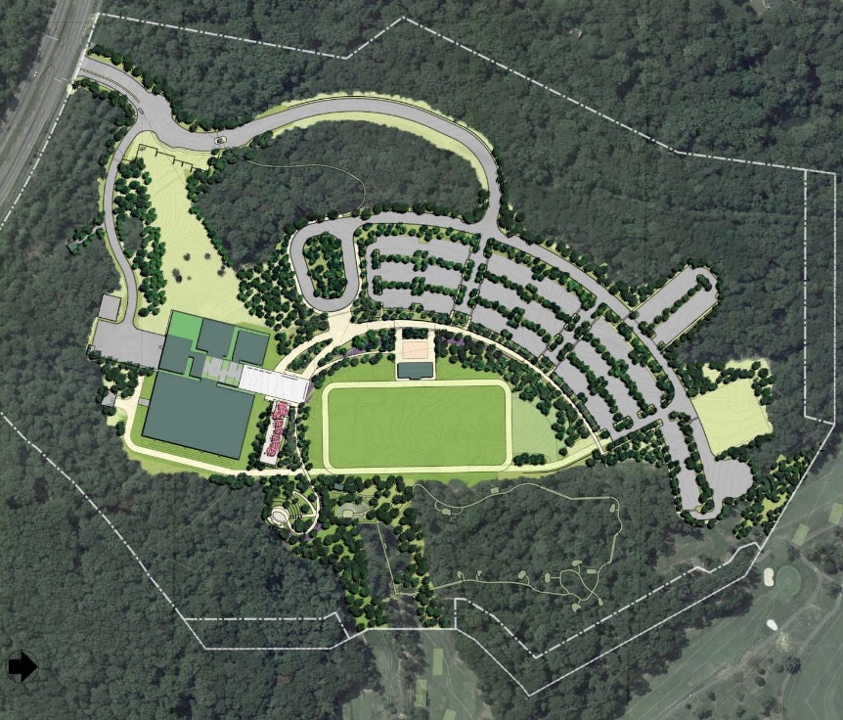
Sighted on a hilltop at Fort Belvoir in Fairfax County, Virginia, the National Museum of the United States Army will be set in the scenic landscape of the Potomac River Valley in Northern Virginia, just south of our nation’s capital. Visitors will have easy access to the Museum campus from the Fairfax County Parkway, just minutes from I-95, one of the most heavily travelled stretches of highway in the nation.

Museum patrons will begin their visit by following a formation of metal pylons, scored with the stories and faces of Soldiers throughout history, marching toward the simple, yet bold glass and steel façade of the Museum. Once inside, illuminated, colorful glass campaign streamers overhead will represent each of the Army’s campaigns. At the southern end of the lobby, an engraved honor wall will commemorate each of the U.S. Army’s battles. An oversized Army emblem will be inlaid into the center of the lobby’s terrazzo flooring.

Moving through the lobby, visitors will first encounter The Army Theater, designed to provide a unique, immersive experience through 360 degrees of video screens that surround the theater’s audience. Just past the theater will be the Army Concourse, leading visitors to galleries that delve deeper into Army history told through full-scale artifacts and interactive exhibits. The Army and Society gallery will track the symbiotic relationship between Army and civilian life. Visitors will explore the impact Army innovations and technology have had on our everyday lives. In the Fighting for the Nation gallery, visitors will walk through the history of the Army from its humble beginnings in 1775 to its emergence as the world’s most advanced and capable global fighting force.

The Museum will offer a unique learning space specially design for young visitors. The Experiential Learning Center will help students develop skills in Geography, Science, Technology, Engineering and Math (G-STEM) as they work in teams to complete Army missions. The Growing Up Army wall will present first person accounts of Army families around the world, highlighting the service of Soldiers’ loved ones. And Fort Discover will offer a hands-on exploration space for small children.

The museum will include special gallery space for temporary installations, a café, and a museum store, which already has an online retail site offering a wide selection of memorabilia and that contributes a portion of its proceeds to the Museum’s construction. There will be two event spaces in the Museum. The lobby will be reconfigured for private events up to 460 guests. The Veterans’ Hall will also provide a formal event space for reunions, banquets, ceremonies and other special events.

Visitors can take their experience outside the Museum, learning Army survival tactics as they wander the interactive Army Trail. The outdoor amphitheater will serve as a focal point for outdoor ceremonies and events, and a parade ground will provide ample space for demonstrations and reenactments. The Museum will also feature intimate garden spaces, where visitors can reflect and pay tribute to the service of generations of American Soldiers. The Medal of Honor Garden will be a tranquil, dignified place for small events and quiet reflection on the service and sacrifice of extraordinary Solders. The garden’s design will memorialize Medal of Honor recipients and will incorporate symbolic references to the qualities recognized by the Medal of Honor – valor, gallantry, and intrepidity.

As a place to both commemorate and educate, the National Museum of the United States Army will provide a welcoming home for veterans, and offer visitors of all ages the opportunity to better understand the role that American Soldiers play in shaping the history of this nation and the world. For Soldiers, it will be an engaging way to explain to their loved ones what they do and why, and an inspiring place to connect with those in whose footsteps they follow.

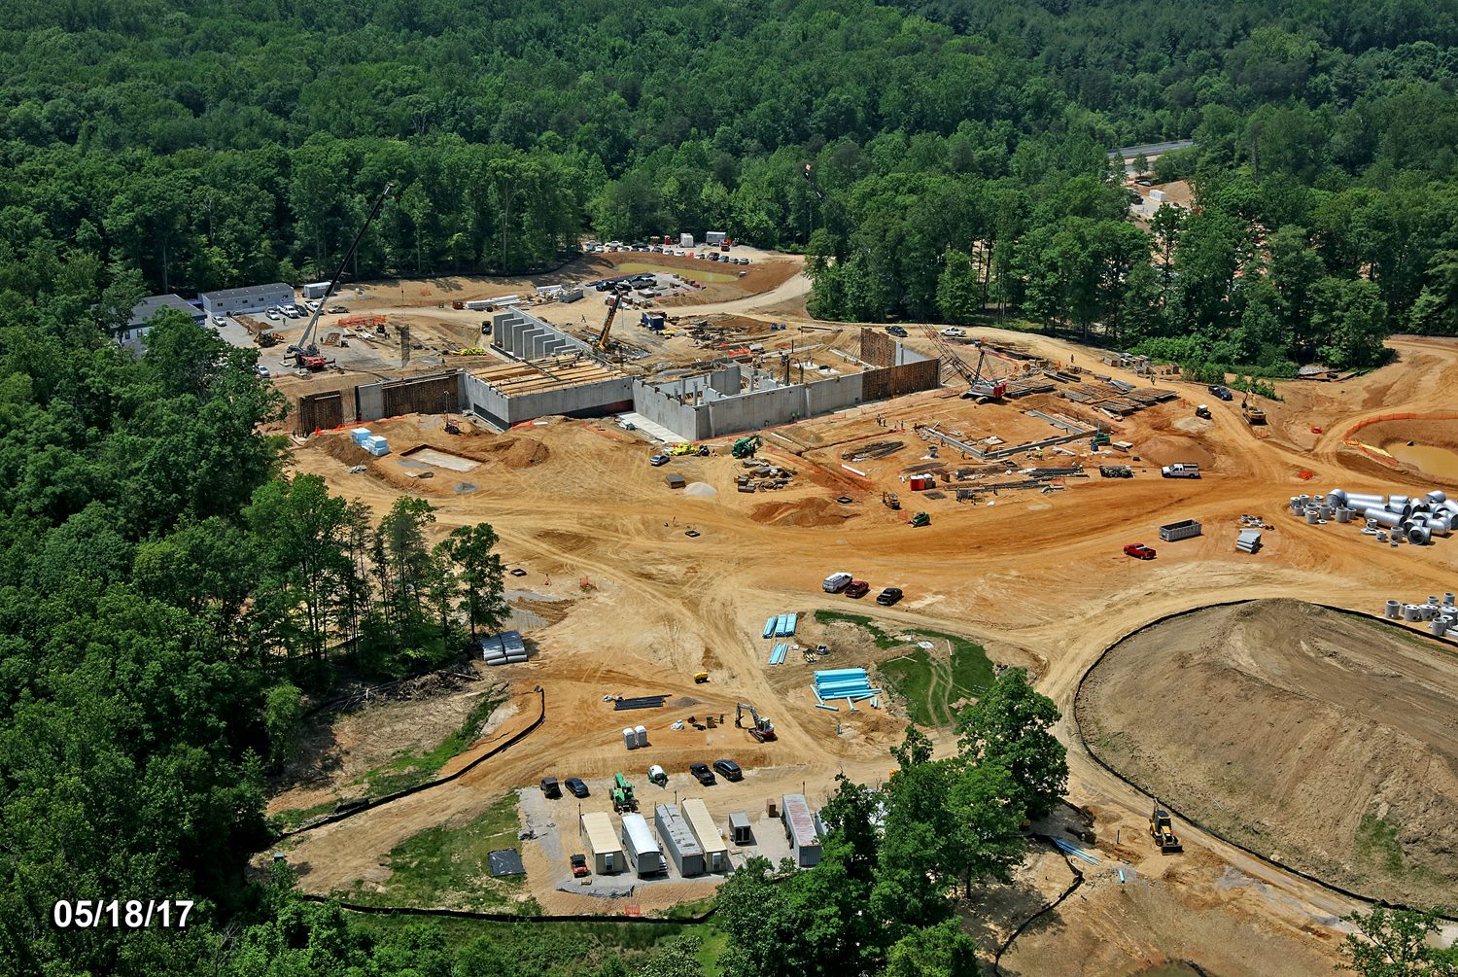

Honoring the American Soldier

Registries
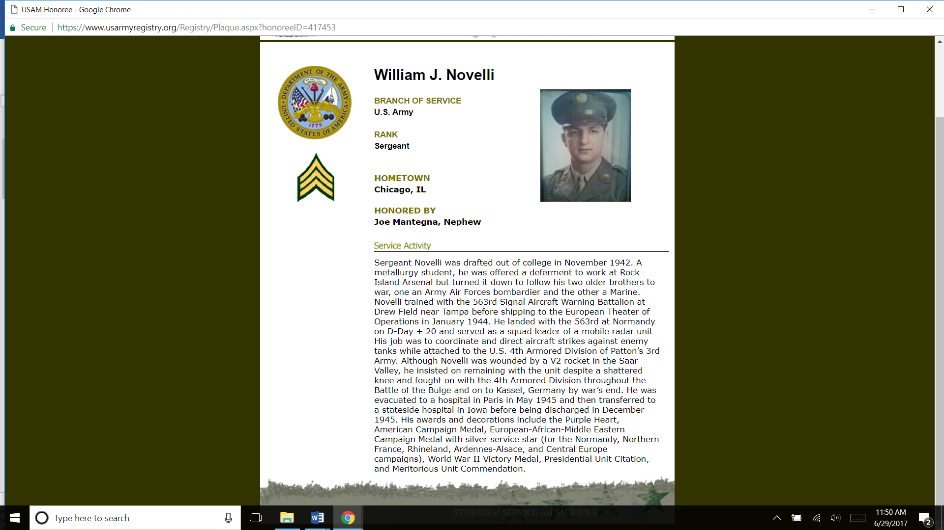
The Army Historical Foundation has produced three digital Registries to recognize and honor active duty Soldiers, veterans, civilians who worked with or for the Army, and animals that served during conflicts. The Registries offer everyone who served honorably in or for the U.S. Army a way to have their names and service history placed on record at the National Museum of the United States Army. Once open, the Museum will hold a permanent display of the Registries for visitors to review for years to come. The Registries will also be accessible online for those who cannot visit in person. Any person may add themselves or another to the Registries, free of charge.

Commemorative Bricks

The Foundation’s commemorative brick program provides Soldiers, Army units, Army families, Department of the Army civilians, and Museum and Army supporters a lasting tribute on the grounds of the National Army Museum. Personalized bricks are available now through the Foundation’s website, ArmyHistory.org. The first bricks to be ordered will be in place once the Museum opens and line the Path of Remembrance that leads visitors to the Museum’s grand entrance.

Veterans’ Hall
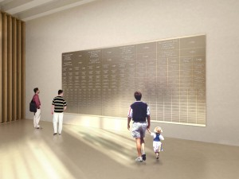
The Veterans’ Hall will provide a unique setting in the National Army Museum to honor the service and sacrifice of America’s veterans. This multi-purpose space will host reunions, meetings, dinners, and official functions in a patriotic atmosphere. The hall will also showcase artwork, artifacts, and the Registries. Veterans Service Organizations and other groups that support the U.S. Army have the opportunity to contribute to this unique space in return for permanent recognition on the Veterans’ Hall wall.

General Gordon R. Sullivan, USA (Ret.)
Chairman of the Board, The Army Historical Foundation
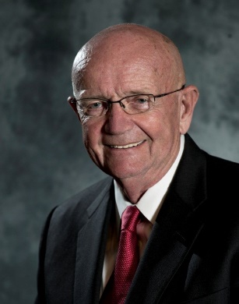
General Gordon R. Sullivan currently serves as the Chairman of the Board of the Army Historical Foundation in Arlington, Virginia. In this capacity, he leads the Capital Campaign to construct the National Museum of the United States Army at Fort Belvoir, Virginia. A tireless advocate for Soldiers and their families, the Museum project remains consistent with General Sullivan’s priorities—to recognize the contributions of over 30 million American men and women who have served in our Army.

From 1998 to 2017, General Sullivan was the President and Chief Executive Officer of the Association of the United States Army, also headquartered in Arlington, where he oversaw the transformation of the association into a dynamic, member-based organization that continues to represent Soldiers, Army families, and the defense industry.

Born in Boston, Massachusetts and raised in Quincy, he earned a Bachelor of Arts degree in history from Norwich University and was commissioned a second lieutenant of Armor in 1959. General Sullivan retired from the Army on July 31, 1995, after more than 36 years of active service. He culminated his uniformed service as the 32nd Chief of Staff—the Army’s senior general officer—and a member of the Joint Chiefs of Staff.

General Sullivan also recently completed an appointment as the Chairman of the Board of Trustees of Norwich University. He currently serves as the Chairman of the Board at the Marshall Legacy Institute and is also a member of the Mitre Army Advisory Board, the MIT Lincoln Labs Advisory Board, and a Life Trustee of the Woods Hole Oceanographic Institute.
In addition to his numerous military awards and decorations, he is also the recipient of the AUSA 2016 George Catlett Marshall Award for selfless service to the United States of America, the West Point Association of Graduates’ Sylvanus Thayer Award and a member of the Sergeants Major Academy’s Hall of Honor.

General Sullivan currently resides in Alexandria, Virginia. He has three children and three grandchildren. He is an avid reader, amateur historian, and active sailor and sport fishing enthusiast.

LTG Roger Schultz, U.S. Army (Ret.)
President, The Army Historical Foundation

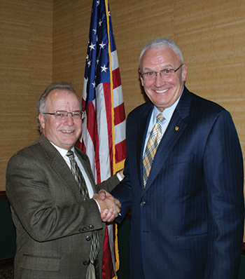
As President of The Army Historical Foundation, Lieutenant General Roger Schultz leads the team carrying out the Campaign to build the National Museum of the United States Army.
LTG Schultz retired from the U.S. Army in October 2005 with 42 years and 9 months of service in the Army National Guard. He was selected for his final assignment on June 1, 1998, when he assumed the role of Director of the Army National Guard. His seven-year tour of duty as Director places him as the longest serving director in the National Guard’s history.
While leading the Army National Guard, LTG Schultz was responsible for the formulation, development and implementation of all programs and policies affecting the Army National Guard. He was also charged with managing the Army National Guard’s $11.7 billion budget. Prior to this assignment, he was called to serve as the Deputy Director of Army Operations.
Over the course of his career, LTG Schultz spent 27 years managing emergency response projects at the state and national level. He served as the Deputy Adjutant General of the Iowa National Guard. He was also assigned as the Deputy Director for Military Support on the Department of the Army Staff. In that capacity, General Schultz was responsible for coordinating all Department of Defense military support to civilian authorities, to include disaster relief operations. Earlier in his career, Schultz also served as the Operations Officer and Chief of Staff for the Iowa National Guard.
LTG Schultz’s military service began in 1963. He served four years as an enlisted Soldier and was commissioned as an Infantry officer following Officer Candidate School at the Iowa Military Academy. He was first called to active duty in 1968, when he was mobilized with a Mechanized Infantry Battalion from NW Iowa. He led both a Rifle Platoon and a Scout Platoon in Vietnam.

BG Creighton W. Abrams, Jr. U.S. Army (Ret.)
Executive Director, The Army Historical Foundation
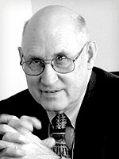
Brigadier General Creighton W. Abrams, Jr. has served as Executive Director of The Army Historical Foundation since 2000. Under his leadership, the Foundation has remained committed to preserving the heritage of the U.S. Army and educating the future about the Army’s contributions to our nation and world, most notably through the current construction of the National Army Museum.
BG Abrams served 31 years in the U.S. Army. Commissioned in the field artillery, he commanded two batteries, a battalion, a division artillery, and a corps artillery. He has served as an American Soldier in Korea, Vietnam, Germany, Southwest Asia, and Italy.
Among his assignments, BG Abrams has taught gunnery at Fort Sill, OK, English at West Point, NY, corresponding studies at the Army War College, and a staff group in the Combined Arms and Services Staff School (CAS3), Fort Leavenworth, KS, where he was the Director for three years. He served on the Army staff at the Pentagon and on the NATO staff at Allied Forces, Southern Europe.
After retirement, BG Abrams worked for General Dynamics Land Systems in Saudi Arabia. He has a B.A. in English from Princeton University, an M.A. in English from the University of North Carolina, and a Masters in Military Art & Science from Command and General Staff College. He and his wife Joan have 6 children.

